
_________________________________________________________________________________

ASSOCIATION OF CHRISTIAN SCHOOLS INTERNATIONAL: SOUTH AFRICA
Enabling Christian Educators and Schools Worldwide

January 2012

Dear Leader

The Association of Christian Schools International (ACSI) African Office is here to serve you. We are a gateway to the support services you need. We bring the strength of our partnership to help you fulfill your Christ-centered mission.

Your ACSI membership is an investment in your school. When you use your membership to the fullest extent, your teachers, staff and students will reap an abundant harvest.

We encourage you to join ACSI today! Please take time to read each document carefully, and prayerfully consider membership with a Christian education association that will assist you, and your school, to effectively prepare students for life.

We offer our member schools the following:

Training Services
- Leadership, teacher and student conferences, seminars and one day enablers.

Consultation Services
- New school consultations, whole school improvement/accreditation visits with on-site consultation support.
- Networking and partnerships between ACSI and member schools, prayer and encouragement.

Academic Publications
- Christian Early Education, Christian School Education, Newsletters and Updates.

Governance
- Policy Governance workshops to assist schools boards and Pastors.

Additional Membership benefits
- Reduced prices on ACSI materials
- Children at Risk Programme

THE APPLICATION PROCESS
Please complete the enclosed application form and return it to our office as soon as possible, and be sure to include the following documents:
- Your membership fee of 200 USD.
- Proof that your school is registered with your local Education Department/State – or is in the process of becoming registered.
- ACSI’s signed Statement of Faith and signed Code of Ethics.
- Your school’s Vision and Mission statement together with the school’s constitution.
- The learner figures that you submit should be the same as those required by your Education Department/State. These are purely for statistical purposes.

Please complete the enclosed forms and return them to our office as soon as possible.

Directors: Dr Brian Simmons (USA), Dr Dan Egeler (USA), Mr Mike Epp (USA), Dr Samson Makhado (Africa)
Advisory Board Members: Mr Gavin Brettenny (South Africa), Professor Derrick Mashau (South Africa), Dr Udofia (Nigeria), Pastor Cobus Sipsma (South Africa), Reverend Theo Poggenpoel (South Africa)

AFRICA OFFICE: 98 13th Avenue Edenvale 1609 P.O. Box 828 Edenvale 1610
Telephone +27 11 452 4174/452 0406 Fax: +27 11 452 8143 www.acsi.org
Association incorporated under Section 21: Registered number 2001/030186/08

THE MEMBERSHIP PROCESS
Once the Africa office in Edenvale, Johannesburg, has received your application, with all the required, completed documentation attached, the following will take place:

- ACSI will check all documentation for completeness.
- Once all the documentation is in place and all formalities have been successfully concluded the school will be formally accepted as an ACSI member school.
- The ACSI membership certificate will be issued once the fees have been paid.

THE INVESTMENT PROCESS
Our passion is to provide strategic services and resources to your school but to do this effectively we need your help with the completion of all the above documents.

Your investment. Your return. Join the Association of Christian Schools International NOW.

Invest in your school today.

Yours in His service,

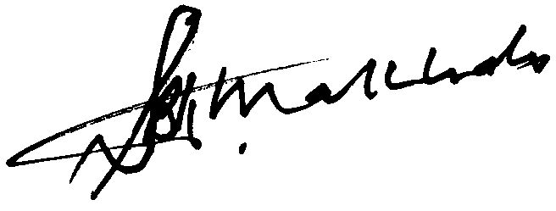

Samson B.K. Makhado Ph.D.
DIRECTOR: Africa

